South East Technological University

University App
Design Specification

Prepared by:
Ihor Melashchenko (C00290950)
Bachelor of Science (Honours) in Software Development, Year 4
Supervisor:
Dr. Joseph Kehoe
19.05.2026

Acknowledgements
Thank you to the project supervisor and peer reviewers for iterative feedback on scope control and implementation quality.

Table of Contents
Acknowledgements 2
Abstract 5
1. Introduction 6
1.1 Design Goals 6
1.2 Technology Baseline 6
2. Architecture Overview 7
2.1 Component Architecture 7
2.2 Deployment Diagram 7
2.3 Class Diagram 8
2.4 UI Navigation Flow 9
3. Modules 10
3.1 Backend Packages 10
3.2 Handler-to-Repository Responsibilities 10
3.3 Module-to-Directory Mapping 10
4. API Design 11
4.1 Versioning and Route Pattern 11
4.2 Authentication and Authorisation 11
4.3 Error Semantics 11
5. Data Design 12
5.1 Schema Evolution Summary 12
5.2 Core Entities 12
5.3 Entity Relationship Diagram 12
6. Sequence Designs 13
6.1 Student Login Sequence 13
6.2 Card Request Processing Sequence 14
6.3 Assignment Submission Sequence 15
6.4 Feedback/Telemetry Sequence 16
Glossary 17
Bibliography 18

Figure 1. Component Architecture 7
Figure 2. Deployment Diagram 7
Figure 3. Class Diagram 8
Figure 4. UI Navigation Flow 9
Figure 5. Entity Relationship Diagram 12
Figure 6. Student Login Sequence 13
Figure 7. Card Request Processing Sequence 14
Figure 8. Assignment Submission Sequence 15
Figure 9. Feedback/Telemetry Sequence 16

Abstract
The University App is a multi-platform super-app (Haines, 2022) that consolidates student services into a single, unified platform. The long-term vision is that the application could operate as a configurable B2B (business-to-business) service for any higher education institution (HEI), similar to how Blackboard functions as a SaaS (Software as a Service) product.
For this project, the development focuses on the ecosystem of the South East Technological University (SETU), incorporating its branding, structure, and service offerings.
The application aims to address a widely recognized challenge across HEIs: fragmented student systems that require multiple logins, offer an inconsistent user experience, and have limited integration.
Project motto: “One app. One login. One student experience.”

1. Introduction

1.1 Design Goals
- Maintain clear separation of concerns between data transfer, business logic, and persistence.
- Support secure role-based access for student and staff/admin operations.
- Keep deployment reproducible for demonstration.
- Provide a structure that can be extended to Android and Web clients.

1.2 Technology Baseline
Layer | Technology | Rationale
Backend API | Go, chi router | Fast, explicit, low-overhead HTTP services
Database | PostgreSQL | Relational integrity for institutional data
Migrations | Goose | Repeatable schema evolution
iOS Client | Swift, SwiftUI | Native iOS user experience
Admin Web Client | React, Vite, Nginx | Efficient admin interface
Local Ops | Docker Compose | One-command local deployment
Cluster Ops | Kubernetes, Kustomize | Portable deployment manifests

2. Architecture Overview

2.1 Component Architecture
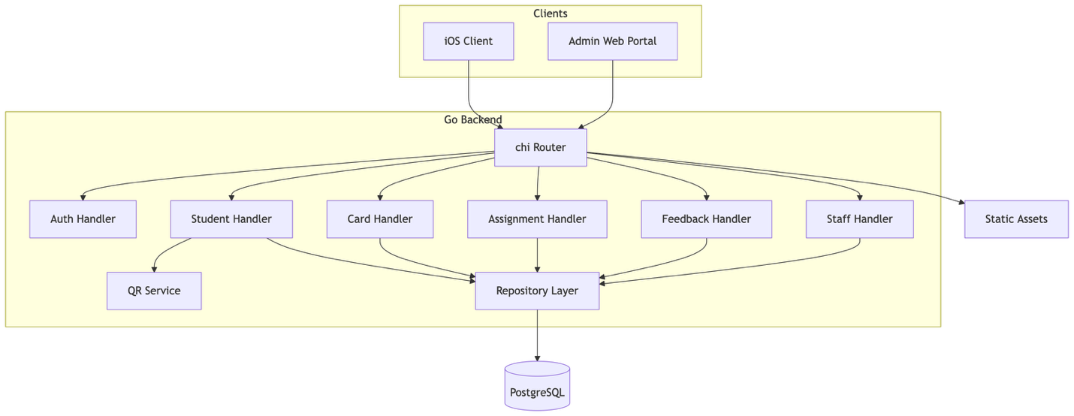
Figure 1. Component Architecture

2.2 Deployment Diagram
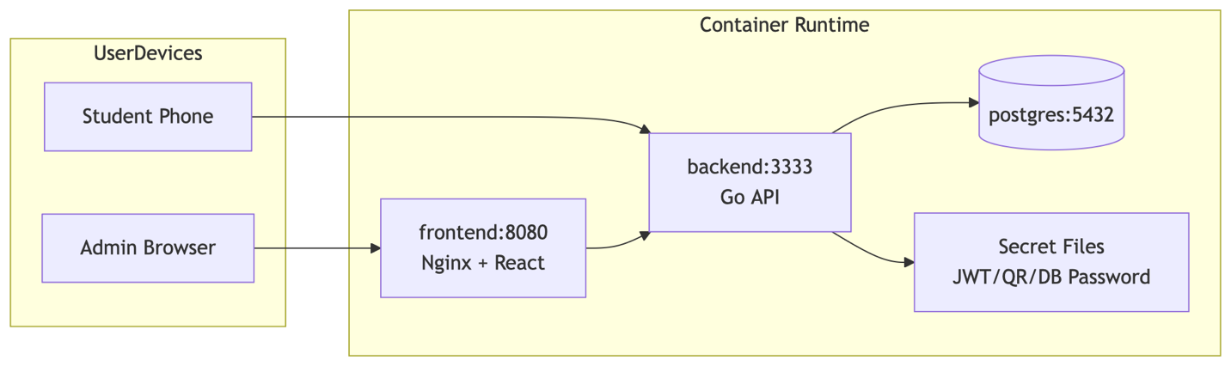
Figure 2. Deployment Diagram

2.3 Class Diagram
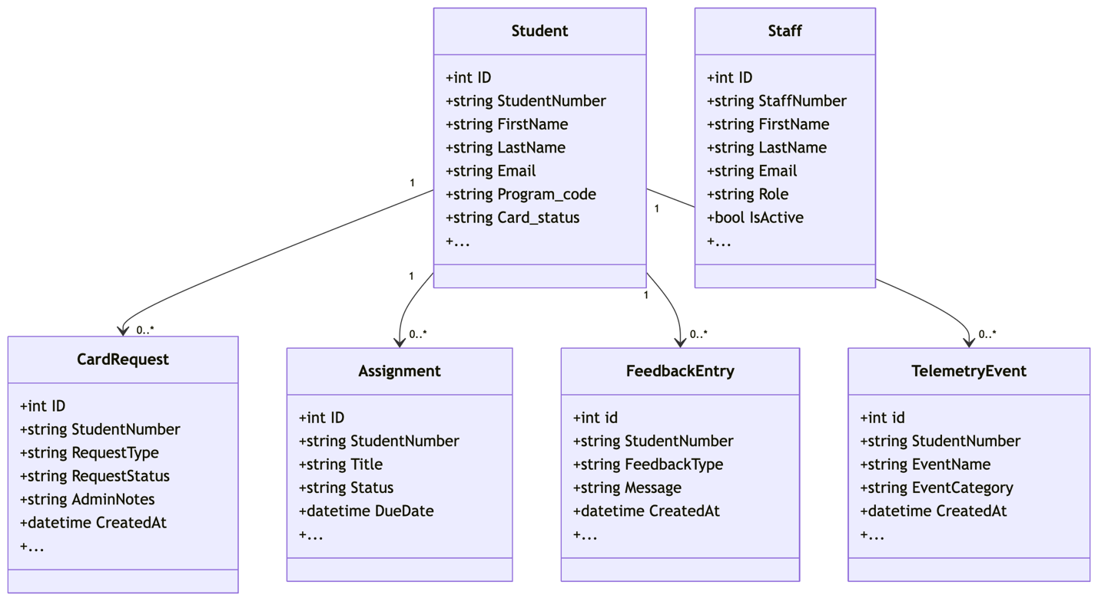
Figure 3. Class Diagram

2.4 UI Navigation Flow
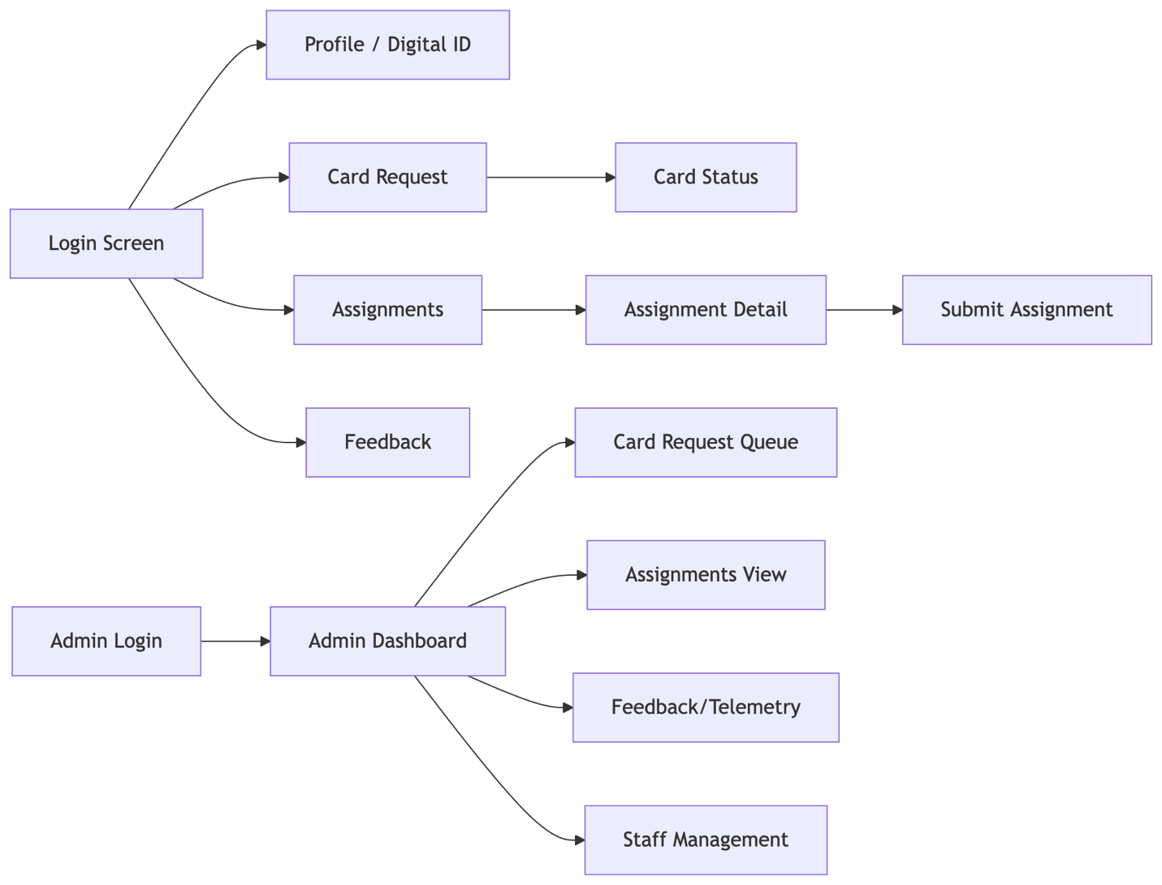

Figure 4. UI Navigation Flow

3. Modules

3.1 Backend Packages
- cmd: application entry point (connect DB, run migrations, start server)
- server: HTTP server bootstrapping and route registration
- handler: request validation, response shaping, auth checks
- repository: SQL access and querying
- model: domain and DTO structs
- service: reusable business logic (e.g., QR and barcode generation)
- config: environment variables and secrets management

3.2 Handler-to-Repository Responsibilities
Domain | Handler | Repository | Key Operations
Authentication | auth_handler | student_repository, staff_repository | login, claim creation
Students | student_handler | student_repository | CRUD, profile retrieval
Student Cards | card_handler | card_request_repository | create/list/status/process
Assignments | assignment_handler | assignment_repository | list/detail/submit/admin list
Feedback | feedback_handler | feedback_repository | create/list and telemetry
Staff Admin | staff_handler | staff_repository | list/create/update

3.3 Module-to-Directory Mapping
Design Module | Implementation Logic
Entrypoint and startup flow | server/backend/cmd/main.go
Route registration | server/backend/server/routes.go
Request handlers | server/backend/handler
Repository layer | server/backend/repository
Domain/DTO models | server/backend/model
Service layer | server/backend/service
Schema evolution | server/backend/migrations

4. API Design

4.1 Versioning and Route Pattern
- Base path: /api/v1
- Resources use noun-based paths
- Admin operations are namespaced under /api/v1/admin/*

4.2 Authentication and Authorisation
- Bearer JWT is required for protected endpoints.
- Student and staff tokens differ by claim context.
- Admin-only routes enforce role checks.

4.3 Error Semantics
- 400 for validation/input issues
- 401 for missing/invalid auth
- 403 for role violations
- 404 for missing records
- 500 for unexpected server/DB failures

5. Data Design

5.1 Schema Evolution Summary
Migration sequence:
- create_students_table
- add_student_card_columns
- create_card_requests_table
- add_profile_details_and_memberships
- create_assignments_table
- create_feedback_and_telemetry_tables
- create_staff_table
- seed_demo_data

5.2 Core Entities
- Student
- Staff
- CardRequest
- Assignment
- FeedbackEntry
- TelemetryEvent

5.3 Entity Relationship Diagram
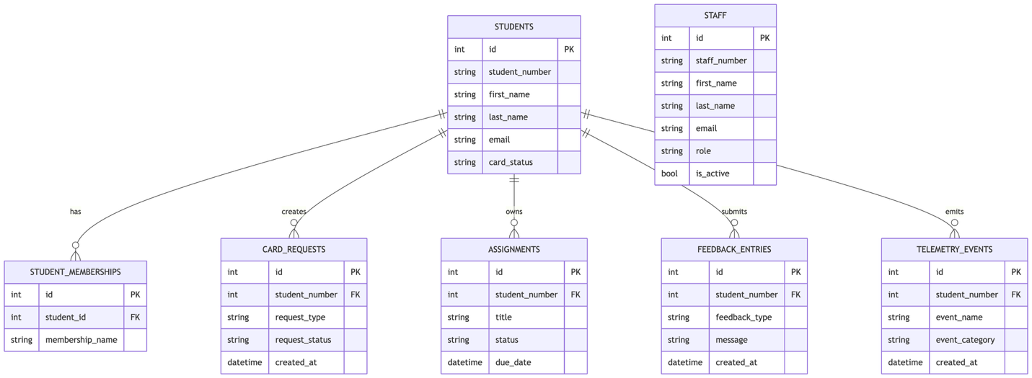
Figure 5. Entity Relationship Diagram

6. Sequence Designs

6.1 Student Login Sequence

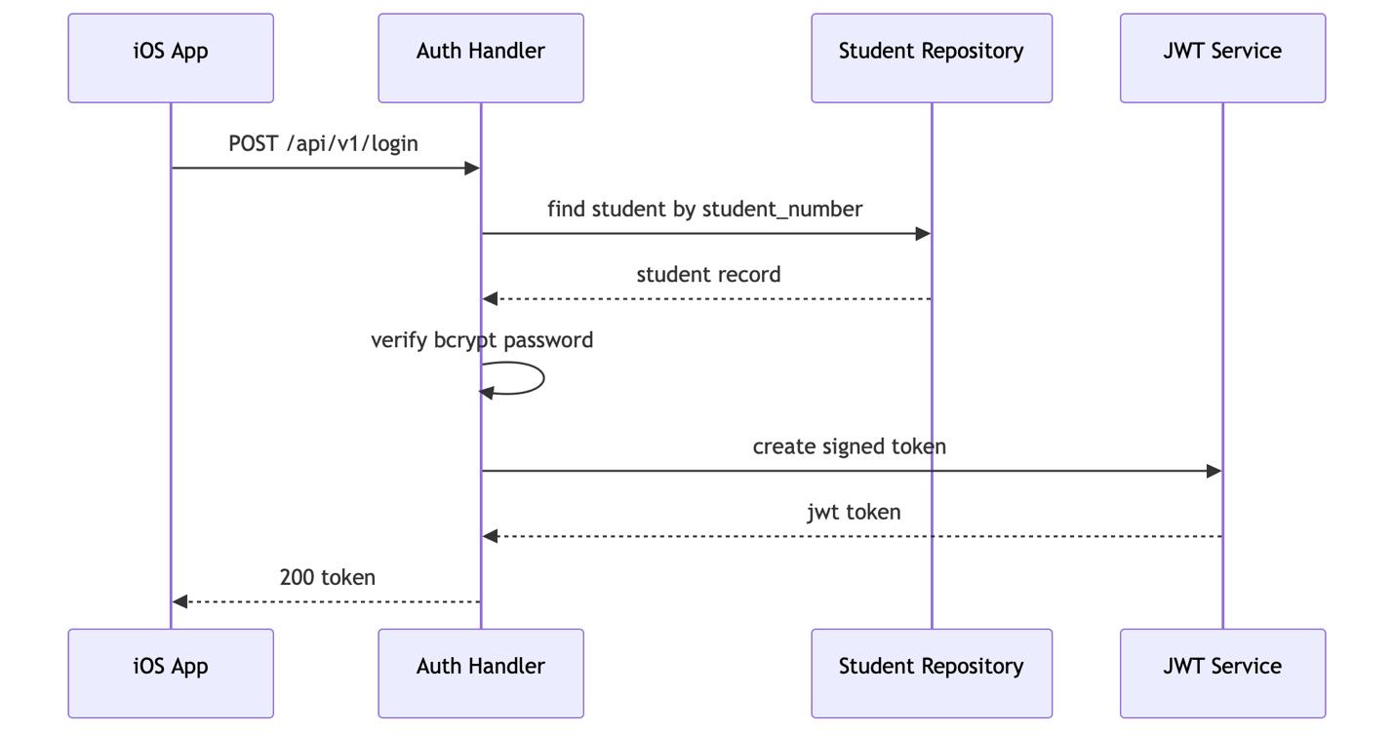
Figure 6. Student Login Sequence

6.2 Card Request Processing Sequence
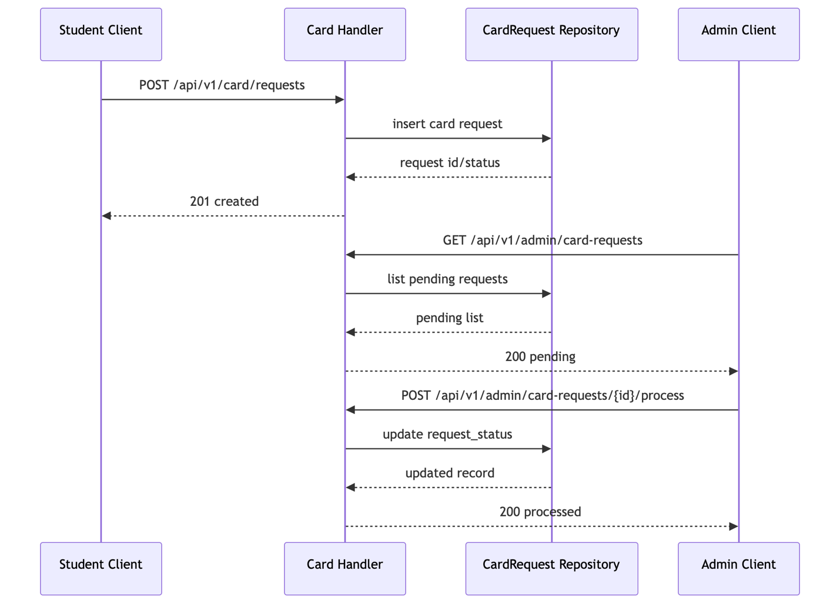
Figure 7. Card Request Processing Sequence

6.3 Assignment Submission Sequence
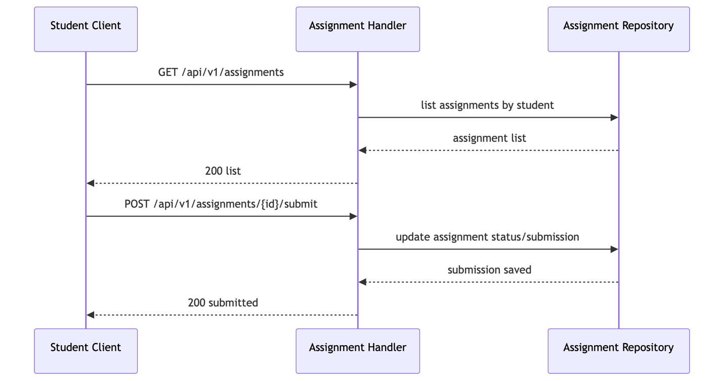
Figure 8. Assignment Submission Sequence

6.4 Feedback/Telemetry Sequence
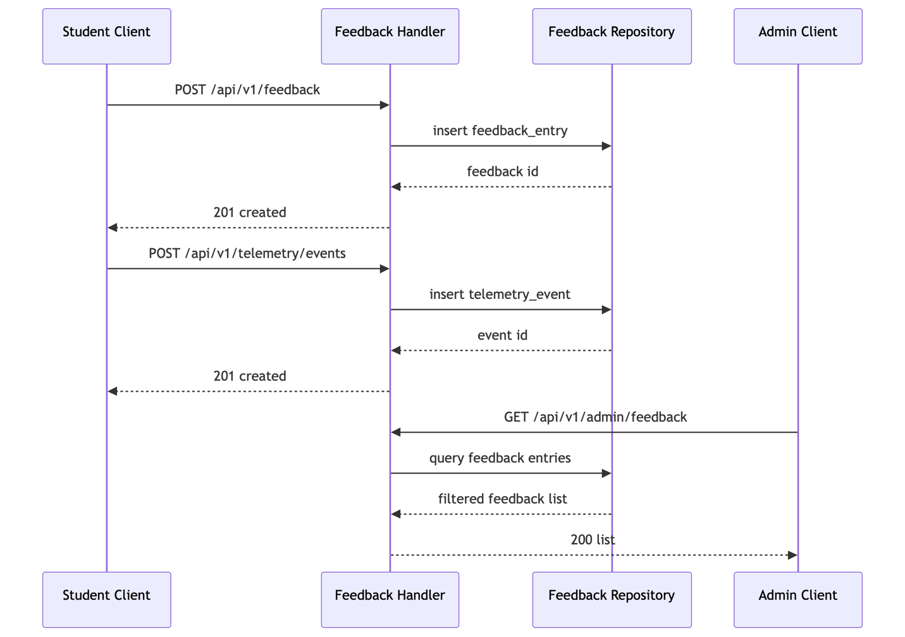
Figure 9. Feedback/Telemetry Sequence

Glossary
- ERD: Entity Relationship Diagram
- DTO: Data Transfer Object
- CRUD: Create, Read, Update, Delete
- API: Application Programming Interface
- JWT: JSON Web Token

Bibliography
Haines, J. (2022). The Super-app Experience. [online] Medium. Available at: https://uxplanet.org/the-super-app-experience-3fd530ac1e5f.
Terminalfour Higher Education Digital Marketing Blog. (2019). Blog - Apple rolls out contactless student IDs to 12 more universities. [online] Available at: https://www.terminalfour.com/blog/posts/apple-rolls-out-contactless-student-ids-to-12-more-universities.html.
Dublin, T.C. (2026). New Trinity ID App. [online] www.tcd.ie. Available at: https://www.tcd.ie/news_events/articles/new-trinity-id-app/.
ID123. (2026). Digital ID Cards. [online] Available at: https://www.id123.io.
Diia.gov.ua. (2018). Digital State. [online] Available at: https://expo.diia.gov.ua.
Mriia.gov.ua. (2024). Мрія — перший освітній державний застосунок для учнів, батьків і вчителів. [online] Available at: https://mriia.gov.ua/en/app.

